Overview
Upon completion of this chapter, the participant will be able to:
Discuss project management goals and required competencies.
List common project risk factors.
Explain how the process groups and knowledge areas are used in the Project Management Body of Knowledge (PMBOK).
Discuss the benefits of Microsoft Project 2010 to support project management.
Differentiate between local and shared resource pools.
Describe the purpose of the Practice Standard for Scheduling.
Project Management as a Discipline
Project management is the discipline of blending time-tested best practices, defined processes, soft skills, and the use of tools and templates, then applying these to initiatives resulting in proactive efficiency. Stakeholder satisfaction is better realized when utilizing a consistent and methodical approach to the management of projects. Also, this systematic approach paves the way for easier measurement and progress tracking of a project.
One of the most used tools is technology to assist project managers in developing schedules capturing scope, progress and project reporting. One of the most popular technology tools is Microsoft Project (hereafter known as Project).
This course will focus on use of the desktop version of Project.
The Project Management Goal
It is often said that tools do not manage projects – people manage projects. In that light, it is important to remember that technology is only a tool.
The use of Project is not the “Silver Bullet” answer to:
Resolving project management deficiencies
Improper change control processes
Risk analysis and change impact assessment
Project is a great tool for:
Tracking of task and schedule progress
Forecasting and value management
Resource management (allocation details)
The Goal
The ability to satisfy the project requirements is the ultimate goal of project management. Satisfy the requirements and undoubtedly you will satisfy the customer. This does not mean that the deliverables will not change, but through managing customer expectations and clear communication revised requirements can be met.
A properly managed project allows a diverse team of customers, sponsors, experts and stakeholders to:
Agree on the deliverables
Work efficiently to deliver the project on time and on budget
Agree at the end that all requirements and specifications have been met
Six Core Competencies
To achieve these goals a project team needs more than their technical skills. High performance project teams excel at these core competencies:
Planning: Build schedules with sufficient detail to enable management of activities and resources.
Milestone management: Use milestones to clarify deliverables and accountability.
Scope control: Use systems to reduce rework and manage scope controls.
Risk management: Continuously assess risks so that they are prioritized, mitigated, and communicated.
Issues management: Capture relevant issues so that they are properly prioritized and efficiently managed.
Communications: Keep sponsors, team members, customers, crossproject contacts, management, and other stakeholders informed and engaged.
Projects More Likely to Fail
Many times projects have significant hurdles to overcome. As a project manager or a member of a project team, you can look for the tell-tale warning signs of a project process that is not working.
Major Risk Factors Leading to Project Failure
The user’s requirements are not accurately understood, clarified, or reconciled. The project delivers a product the customer does not like or does not use.
Failure to control scope creep and added feature enhancements. Estimates show that over half of the effort expended on many projects is outside the original project scope and plan. Much of the new work is poorly documented and un-budgeted.
Technical/feature specifications change too often along the way. The project wastes time and resources doing rework.
Loss of management support. When corporate priorities shift projects may become casualties.
Team is not aligned on the same outcomes. The team fails to clearly understand what outcomes the customer is expecting and, therefore, internal confusion jeopardizes project success.
Lukewarm support from key people. Stakeholders say “yes,” but resources are not allocated and work is not properly prioritized.
Failure to have a plan with adequate details and controls. Too much time is lost coordinating details which often results in inadequate or late deliverables.
Failure to agree on how decisions are made. Decisions made by the wrong people or at the wrong time result in suboptimization, staff frustration, and rework.
Inadequate coordination between teams and between organizational/departmental silos. Results in duplications, incompatibilities and rework.
Lack of an adequate adoption and learning plan. The best product in the world fails when people are not motivated to use it, are not organizationally structured to use it, or lack the skills and know-how to use it effectively.
It is up to the project team, and ultimately the project manager, to watch for these common hindrances to projects and put efforts in place to counteract ill effects that can damage project success.
Project Lifecycle Management
Project Lifecycle Management
Complex project management processes require tools to manage them. People tend to use what they have available, are already familiar with, and already use. This is why Microsoft Office Excel is often used in smaller project management initiatives. For many projects, Excel is sufficient.
However, it does not take very much complexity – higher number of tasks, multiple interrelated schedules, resources, requirements, deliverables, and departments – to exceed Excel’s project management capabilities. Advanced software applications have been developed to support and facilitate many levels and styles of project management – from simple, high-level schedules to complex, integrated enterprise solutions.
Project management processes can become very multifaceted. One of the risks of complex processes is that they tend to be ignored in practice, resulting in inconsistent results, idiosyncratic management, and frustration.
Strategic project management methods and consistent project management processes need tools designed specifically to support them to be truly efficient and effective. The leading application on the market specifically designed to support project management is Project.
Project is a powerful relational database program that can be configured for use on a single client PC in Project Standard or Project Professional. But its capabilities to facilitate and automate enterprise-wide project management processes within a networked system are limited. For organizations that are seeking an integrated, enterprise-wide project and portfolio management solution, Microsoft has developed Project Professional to integrate with Project Server.
As defined by the A Guide to the Project Management Body of Knowledge (PMBOK® Guide) – Fourth Edition, a project is a temporary endeavor undertaken to create a unique product, service, or result. The temporary nature of projects indicates a definite beginning and end. The end is reached when the project’s objectives have been achieved.
Project management, then, is the application of knowledge, skills, tools and techniques to project activities to meet the project requirements.
The PMBOK breaks projects into 5 Process Groups and 9 Knowledge Areas for management of a project. The 5 Process Groups are:
Initiating
Planning
Executing
Monitoring & Controlling
Closing
The relationship of the 5 Process Groups are outlined in Figure 1-1.
The 9 Knowledge Areas span the 5 Process Groups to provide the basis for managing a project. The Knowledge Areas are:
Project Integration Management
Project Scope Management
Project Time Management
Project Cost Management
Project Quality Management
Project Human Resource Management
Project Communications Management
Project Risk Management
Project Procurement Management
Each intersection of Group and Knowledge Area may have deliverables. Each deliverable is broken out into the following format:
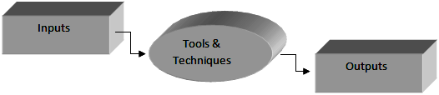
Project Inputs, Tools, and Outputs
The inputs are applied using tools and techniques to get the resulting outputs.
Leveraging Technology for Project Management
Why use Project?
Projects have become a strategic vehicle for leading change. Utilizing technology to support higher success rates of projects is integral for supporting this change and driving continuous improvement.
Some examples of organizational projects are:
New product and service development projects
Process improvement projects
Policy and organizational development projects
Technology development and implementation projects
Focused activities to deliver specific outcomes for clients
Organizations are pursuing more and more different kinds of projects every day.
For some organizations, projects are a small, but an important part of their business. Many organizations are projectizing their strategic work – so they can more effectively focus on key initiatives.
For others, projects are their business. From architects, builders, engineers and construction companies to marketing teams, IT organizations, and software developers… projects define their work.
The demand for effective, consistent project management has grown rapidly over the last decade. Project management has rapidly become a core area of management knowledge and practice. The role of a project manager has become very common in organizations.
The question project management focuses on answering is: what are the processes that lead to successful projects?
Different Project Lifecycle Approaches
The project management discipline has developed into a core area of organizational management. Different industries have developed project management methodologies that address their specific workflows and issues. Architects, construction companies and property developers have developed a set of project lifecycles that reflect certain standard processes from land planning and acquisition, to permitting and design requirements. Other industries, such as software development, have developed different methodology and processes to accommodate their environment.
The rapid growth of the project management field has spawned a number of professional associations. The Project Management Institute (PMI) is the largest global project management professional association in the world today and it is continuing to grow rapidly. The most widely used standard for project management has been developed by the PMI.
PMI
PMI has developed a very extensive library of project management standards, references and tools. PMI has collected the most comprehensive reference on project management standards in a book called The Project Management Body of Knowledge – affectionately called “The PMBOK.” The PMBOK defines a certain standard for project management practices, which many industries follow.
Project has been developed to support a range of PMBOK-aligned project management approaches. It can be configured to support other approaches, such as Scrum and Agile, but organizations employing these methodologies need to adjust their use and expectations of Project as a scheduling and management vehicle.
Technical Lifecycles (Agile to Scrum)
There are other approaches to project management that have been developed by and for project managers in different fields and industries. Two approaches used fairly widely in the technology sector are called Scrum and Agile.
The software development and technology industries have developed approaches to project management that reflect the need of short design-build iterations to facilitate integrating emerging requirements into new product development processes. These tend to focus on shorter iterations and progressive requirements definition.
It might be said that where the PMBOK methodology focuses on thorough planning before project execution, Scrum and Agile focus on minimizing the time between project initiation and execution, and repeated cycles of design, build, test, redesign, rebuild, and test.
Industry-Specific Lifecycles
Some industries and fields that have developed their own project management methodologies and lifecycles include:
Construction
Architecture
Information Technology
Software development
Property development
Project and Project Server are able to be configured and utilized to support many different project management processes, and is especially applicable to projects with longer life cycles, from one month up to the year 2049.
Resource Management
Working with and managing resources is crucial to effective project management because resources accomplish the actual work to create deliverables. Every schedule you create offers a wide range of resource features to support your needs; however, each resource is assumed to be schedule-specific, which may not be true for your organization.
Project desktop offers you the option to create a locally shared resource pool; while not as powerful as what is available in Project Server, it does offer some centralized management of resources.
For an introduction to shared resource pools, see Overview of a Shared Resource Pool, on page 304.
Demand & Capacity Planning
By creating time-phased schedules of work, tasks, deliverables and activities, you are in a position to do forecasting of incoming or existing work.
By adding resources in Project, whether from an external resource pool or from an internal resource sheet, you add the capability to do capacity planning for cost, work and materials.
This is an extremely important feature that executives, stakeholders and project/program managers are looking for. The ability to compare planned work, cost and effort to existing capacity will rapidly help organizations realize the Return on Investment (ROI) from using a scheduling tool.
This also allows you to start leveraging metrics to produce reports, visuals of the workload or anticipated workload.
Microsoft’s Project Management Solution
Microsoft offers a variety of software solutions that can be used to map with organizational maturity levels and desired levels of collaboration. The following graphic illustrates recommended mappings. This book focuses on the Project Professional and Project Standard versions of Microsoft Project which provide features for both basic and advanced project management.
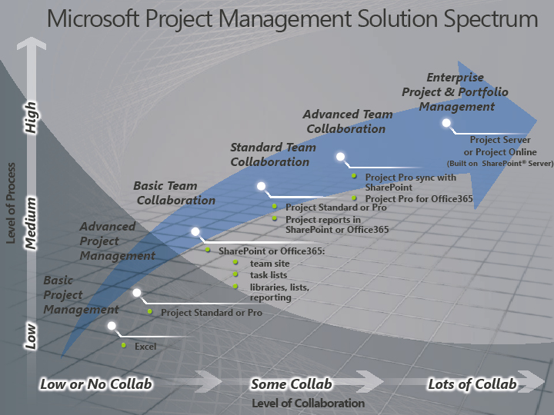
The Microsoft Project Management Solution Spectrum
Project Professional vs Project Standard
In Project 2010, there are two editions for desktop users. Project Standard offers all the typical schedule features needed for most users and includes features that have been available in previous releases. This edition is suited for the individual scheduler that will not be using Project Server.
Project Professional has two purposes. First, it contains advanced scheduling features for the desktop user that are not available in Project Standard. Second, it is the only desktop version that will connect to Project Server. Since this book is written for both editions, we will indicate which features are only available in Project Professional.
Project Server
Some organizations will not only use the desktop version of MS Project, but they will centralize those schedules and resource pools in a web-based, SQLbased environment. This is called Project Server and it provides a significant stabilization of project and resource information, while simultaneously enabling web based viewing, tracking, progressing and reporting (in SharePoint).
For further information on this, take our Managing Projects with Microsoft Project course. Public and private classes are available.
http://managing-projects-with-microsoft-project-2010.eventbrite.com/
Tracking and Managing Planned vs Actual
Project gives project managers and teams the ability to create project schedules, and save their original plans reflected as saved baselines. Once the schedule has been approved (in full or for a particular project phase), it is recommended that the project manager baseline their schedule just prior to work beginning. This will create a historical record of the original approved schedule plan.
These baselines give project managers and organizations the ability to compare and analyze actual project performance. Items such as resource work hours, task progress and realized costs can be analyzed against the latest baseline to measure variances and forecast organizational needs to ensure the project remains on track, and what measures, if any, must take place to align actual progress against expectations. This data can help guide lessons-learned sessions, process improvement projects, team reviews, and even performance bonuses.
Following the guidelines presented in this book project managers will be able to perform resource management including anticipating resource demands and accurately planning and tracking a schedule.
PMI’s Practice Standard for Scheduling
Due to requests by the project management community, PMI created extensions to its most popular book, the PMBOK. One of these extensions is the Practice Standard for Scheduling. This particular extension was created out of the need to provide guidelines on something that most project managers do every day – schedule. While not specific to any scheduling tool, you will be happy to know that Project does conform as a schedule model according to their Conformance Assessment Process, which means Project has all the required software components needed to function as a valid schedule tool.
The purpose of this extension is to provide best practices for the creation of a schedule model. It is not to recommend particular software, but instead provides components that should be considered as required in your selected scheduling software. A good schedule must have both a strong scheduling framework and a baseline schedule. Each of these two areas are discussed in detail in the standard. A large portion of the standard contains a components list that you can use to help communicate with others about elements in a schedule. In terms of Project, many of these components are called fields.
Some of the important definitions made in the standard:
Scheduling is all about the “roadmap” of how you plan to deliver the project.
Schedule Method – how you want your information calculated to generate a schedule (e.g., critical path method).
Scheduling Tool – software that is capable of applying your schedule method.
Schedule Model – a scheduling tool that implements a scheduling method generates a schedule model.
In our instance, Project uses the information you provide against the critical path method of scheduling and generates a schedule model. The schedule model is a dynamic representation of how project activities will be executed by the resources.
Project Schedule – this is one output of the schedule model which could include a bar chart.
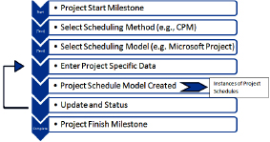
The Schedule Development Process
Some differences between the Practice Standard for Scheduling and this book:
Our book discusses estimating tasks with duration or work values before adding resources, while the Practice Standard adds resources before estimating tasks. You can do these items in either order in Project and still have a valid schedule.
Our book discusses task relationships/linking before assigning resources while the Practice Standard does the reverse. You can do these items in either order in Project and still have a valid schedule.
Project uses the term Status Date, while the Practice Standard uses Data Date.
The Practice Standard states that a valid schedule model must include both a start and finish milestone which all activities must connect to. We consider this a personal choice and schedules can still be valid even if these two milestones are not present.
The Practice Standard recommends limiting the use of lags and negative lags (leads) and instead adding extra tasks or modifying relationships. In our experience, it is your personal preference to use lags/leads or not.
The Practice Standard for Scheduling is available at no charge online to PMI members or available in the PMI bookstore for non-members.
The Practice Standard for Scheduling was updated to the Second Edition in 2011.
Key Points to Remember
Project management can become more disciplined by applying a technology such as Project.
Your plan should be to satisfy your goals and the goals of your customer.
Use technology to support high rates of project success.
Choose the lifecycle approach that fits your industry or type of project.
Managing resources is critical for the success of your project.
Follow the Practice Standard for Scheduling where appropriate.

